Curriculum Policy – 2025

This is a whole school policy which applies to all sections of the school. This policy should be read in conjunction with the following policies: EYFS Curriculum Policy, Safeguarding Policy, EAL Policy, SEND Policy, RSE, PSHEE, Assessment Policy, Reporting Policy & Curriculum Planning.

Introduction

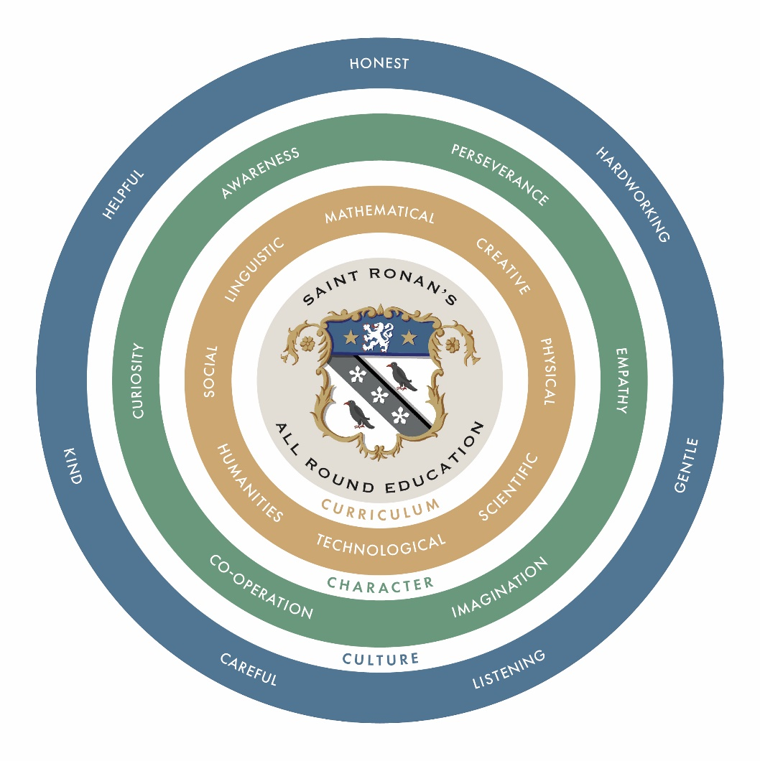

By combining the three Cs of Curriculum, Character and Culture, Saint Ronan’s offers an excellent all-round education, preparing children for whatever their future may hold.

The curriculum is broad and balanced and equips the children with knowledge, skills and understanding.

Building character is key. Children need to develop their ‘soft skills’ to ensure they are best prepared for the challenges of their future education and their role in society.

Operating within a supportive school culture, which fosters emotional as well as intellectual intelligence, is essential.

As detailed in the school’s prospectus, the aims and ethos of Saint Ronan’s are as follows:

Aims
- To provide the children with an excellent all-round education with a suitable range of curricular and extra-curricular opportunities.
- To provide inspiring teaching which promotes both learning and achievement.
- To encourage the children’s spiritual, moral, social and cultural development.
- To provide highly effective pastoral support and guidance.
- To maintain a constructive relationship with parents and carers.
- To ‘mind the magic’.

Ethos
The school has a distinctive character, and it is this charm, this magic, that people fall in love with. It is a family school with an informal and happy atmosphere where staff are approachable and mud unremarkable. In a world where children seem to grow up ever faster, Saint Ronan’s provides a happy environment for children to remain just that. We want the children to enjoy school, relish the opportunities offered and be inspired to work hard, to be kind, gentle, courteous, and honest.

What Really Matters
Our motto Floreat Saint Ronan’s means “let Saint Ronan’s flourish”. We all want this to happen. So, what really matters?
- We are gentle – we don’t hurt others.
- We are kind and helpful – we don’t hurt anyone’s feelings.
- We listen – we don’t interrupt.
- We are honest – we don’t cover up the truth.
- We work hard – we don’t waste our own or others’ time.
- We look after property – we don’t waste or damage things.
Thus, we treat each other as we would like to be treated.

Ronian Characteristics
At Saint Ronan’s we recognize that the children’s sense of happiness and wellbeing is paramount to their achievement in all areas of the curriculum. We will emphasise intellectual mastery and academic ambition by promoting the following characteristics in our pupils:
- Curiosity
- Awareness
- Empathy
- Imagination
- Perseverance
- Cooperation

Saint Ronan’s endeavours to:
- Provide experience in linguistic, mathematical, scientific, technological, human, social, physical, and creative education.
- Ensure all children acquire speaking, listening, literacy and numeracy skills.
- Provide outstanding extra-curricular opportunities especially in music, drama, art and sport.
- Create a happy and secure learning environment where all children are valued.
- Enable all children to learn and develop their skills to the best of their ability and to develop their potential.
- Promote a positive attitude towards learning so children enjoy coming to school and acquire solid basis for life-long learning.
- Help children develop curious and imaginative minds where they question rather than merely accept.
- Help children acquire knowledge and understanding which will equip them for future challenges.
- Help children obtain skills that they can transfer to other subjects and situations.
- Help children understand the importance of truth and fairness so that they grow up committed to equal opportunities for all.
- Enable children to be positive citizens in society, have respect for themselves and be able to live and work cooperatively and confidently with others.
- Teach children to understand right from wrong.
- will encourage a growth mindset across a wide variety of activities with effort, as well as success, being celebrated.
- Actively promote and uphold the fundamental values of democracy, the rule of law, individual liberty, mutual respect and tolerance of those with different faiths and beliefs.

Saint Ronan’s Curriculum is designed to:
- Engage, motivate, challenge and sustain the interest of every child, whatever their ability, and build their confidence and self-esteem.
- Offer a broad, balanced and enjoyable curriculum which is tailored to the needs of the children and their future aspirations.
- Ensure the spiritual, moral, social and cultural values are recognised, addressed and developed.
- Consider the ages, aptitudes and needs of all children, including those children who have SEND and/or disabilities or an EHC plan.

Under the guidance of our teachers, the children should learn to:
- Develop a positive attitude to learning and a growth mindset.
- Strive to achieve their potential and be the best they can be.
- Develop the ability to think independently and work creatively.
- Learn to research, plan, structure and share their ideas.
- Work with others, being respectful of their views.
- Recognise that learning takes place outside the classroom as well as within.

Structure of the Curriculum:
- EYFS (Nursery and Reception)
- Key Stage 1 (Year 1 and 2)
- Key Stage 2 (Year 3 to 6)
- Key Stage 3 (Year 7 and 8)

Early Years Foundation Stage Curriculum
The Early Years Foundation Stage is distinct in its identity. The curriculum is planned in accordance with the ‘Statutory Framework for the Early Years Foundation Stage Framework’.

Under the guiding theme of Learning and Development there are seven clear areas. The three prime areas are:
- Communication and Language
- Physical Development
- Personal, Social and Emotional Development
These prime areas are strengthened and applied through four specific areas:
- Literacy
- Mathematics
- Understanding of the World
- Expressive Arts and Design
Please see the EYFS Curriculum Policy for further detail.

Key Stage 1
Key Stage starts at the beginning of Year 1 and ends at the end of Year 2. We broadly follow the National Curriculum (2014) Programme of Study. Children are taught in mixed ability class groups throughout Key Stage 1.

The core subjects are:
- English
- Mathematic
- Science
- Computer Science

Foundations subjects are taught through topic work and include:
- Design and Technology
- History
- Geography
- Art
- Music
- Physical Education
- Religious Education
- PSHEE
- French

Key Stage 2 and 3
We broadly follow the National Curriculum Programmes of Study and prepare children for the ISEB Common Entrance Exams.
The subjects are:
English
Mathematics
Science
French
Geography
History
Theology, Philosophy and Religion
Computer Science
Music
Art and Design Technology
Physical Education
Games
Drama (up to Year 5)
PSHE (up to Year 5)
Reasoning Skills (Year 5)
Latin (introduced in Year 6)

Curriculum Allocation per week (35-minute lessons):

 | Y1  hours | Y2 hours | Y3  lessons | Y4  lessons | Y5  lessons | Y6  lessons | Y7  lessons | Y8  lessons
English | 5.5 | 6.5 | 9 | 7 | 6 | 6 | 5 | 5
Maths | 4.5 | 4.5 | 8 | 7 | 7 | 6 | 5 | 5
Science | 1 | 1 | 2 | 4 | 4 | 6 | 6 | 6
French | 0.5 | 0.5 | 2 | 3 | 4 | 4 | 4 | 4
Geography | 0.5 | 0.5 | 1 | 2 | 2 | 2 | 3 | 3
History | 0.5 | 0.5 | 1 | 2 | 2 | 2 | 3 | 3
Philosophy and Religion | 0.5 | 0.5 | 1 | 2 | 2 | 2 | 2 | 2
Latin |  |  |  |  |  | 2 | 3 | 3
Art | 1 | 1 | 1 | 1 | 1 | 1 | 1 | 1
Engineering and Design |  |  | 1 | 1 | 1 | 1 | 1 | 1
Music | 1.5 | 1.5 | 2 | 2 | 2 | 2 | 1 | 1
PE | 2 | 2 | 2 | 2 | 1 | 1 | 1 | 1
Computer Science | 0.5 | 0.75 | 1 | 1 | 1 | 1 | 1 | 1
Drama |  |  | 1 | 1 | 1
PSHEE | 0.5 | 0.5 | 1 | 1 | 1
Reasoning |  |  |  |  | 1
Forest School | 1 | 1 | 1
Child Initiated | 1 | 1
Games |  |  | 9 | 9 | 9 | 9 | 9 | 9
TOTAL LESSONS |  |  | 43 | 45 | 45 | 45 | 45 | 45

A dedicated hour of PSHEE for Y6-8 children takes place each half term. See our PSHEE policy for more detail.

Equal Opportunities and Challenge for All

At Saint Ronan’s all pupils are equally valued and have the same rights and entitlement to access the curriculum. As children all develop at different rates so teaching and learning should be differentiated. Saint Ronan’s considers the age, aptitude and needs of all the children.

Use of subject setting

From Year 4 children may be grouped into sets in Maths and English. The sets reflect the children’s current level of attainment. The groups are reviewed after each set of exams. Decisions to move children into a different set are evidence-led (e.g., exams, standardized test, teacher judgment). Setting may occur in other subjects from Year 5.

Setting arrangements may be changed from year to year, taking into account the educational and emotional needs of each particular year group.

Use of Graduated Success Criteria

The school has taken the strategic decision to go beyond the traditional approach to provision for children considered to be able, gifted or talented. Instead, the school uses graduated success criteria to ensure that all children can know when they are challenging themselves. This complements the school’s belief in Growth Mindset, recognising that:
- Every high achieving child had to start somewhere (and may have not always been starting from a position of perceived strength).
- Success tends to lead to success and a culture of positivity.
- Access to challenge and success should be open to all and not just those considered to be able, gifted or talented.

Graduated Success Criteria process:

- The teacher decides prior to the lesson / unit of work if graduated success criteria is appropriate.
- The teacher then decides, in relation to the desired learning outcomes, how a high achieving child might demonstrate that he/she has gone beyond the task (i.e., gone deeper with their learning, towards mastery).
- The teacher then designs the success criteria in a way that is accessible to the class. This shows how the children can achieve different levels of success in relation to the activity. This might be called ‘Walk / Jog / Run’ (with ‘Walk’ representing what the teacher would normally expect and ‘Run’ going significantly beyond expectations), but can also be referred to as ‘Challenge’ etc.
- There will normally be a reference guide (either printed out and stuck into children’s books, or on the board in class) so that the children can reflect on their own level of success.
- This might form the basis for self-/peer- assessment as well as marking and feedback.
- At a more advanced level, the children will design their own graduated success criteria.

Teachers may decide when to use graduated success criteria but are expected to use them regularly. This is monitored in the work scrutiny process, overseen by the Academic Management Team.

Special Educational Needs & Disabilities (SEND)

All pupils are entitled to access the full school curriculum and to take part in every aspect of school life unless there is a specified modification or disapplication outlined in an individual pupil's Statement of Special Educational Need or EHC (Education and Health Care Plan).
The School follows the SEN Code of Practice 2014 approach to the identification, assessment, and review of pupils with special educational needs. The four key actions are Assess, Plan, Do, Review. Pupils with additional learning support have an individual pupil profile (IPP).

English as an Additional Language (EAL)

Provision for children with EAL is managed on a case-by-case basis and overseen by the Head of Pre-Prep and Deputy Head (Academic) in consultation with the SENDco. Targets are identified for each child and reviewed each term.

Schemes of Work

Each department is committed to developing a curriculum that engages and excites all children at school. The curriculum provides an appropriate level of challenge for every child and is geared towards helping children develop as learners and ensures they are best prepared for transition to an appropriate senior school.

Course outlines for each department can be found on the school website.

Assessment
Each department utilizes several assessment methods, both summative and formative, to ensure constant monitoring of learning progress for every child. Assessments are also used to give the school a national context for their curriculum delivery in Maths, English and Science. These are called Progress Tests. Assessments are used to help identify children who may have specific barriers to learning and to ensure curriculum delivery is appropriately differentiated for these individuals. The assessment framework provides teachers with the necessary information to plan teaching so that pupils can always continue to progress. Please see our assessment policies for more detail.

Reporting
We provide a schedule of written and verbal reports throughout the year. Please see our reporting policies for more detail.

Review
The School will review this policy on an annual basis.
Review Framework

Dale Bright
Reviewed: January 2026

